**PIZZA SALES SQL QUERIES**

**A. KPI’s**

**1. Total Revenue:**

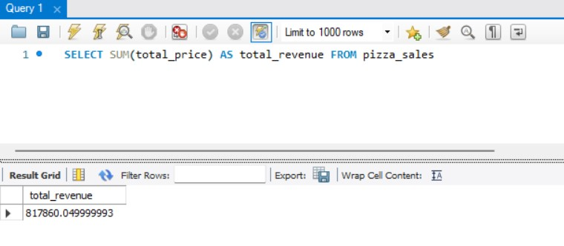

**2. Average Order Value**

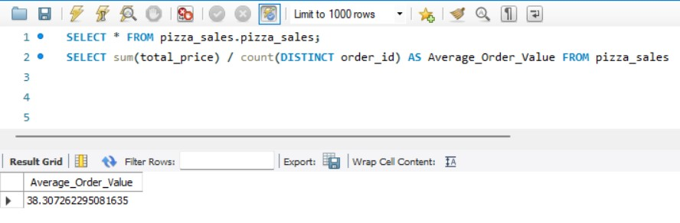

**3. Total Pizzas Sold**

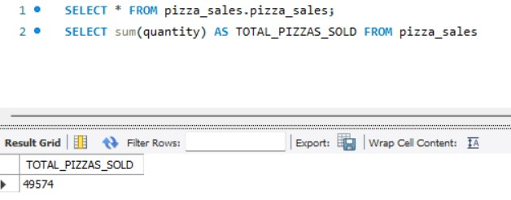

**4. Total Orders**

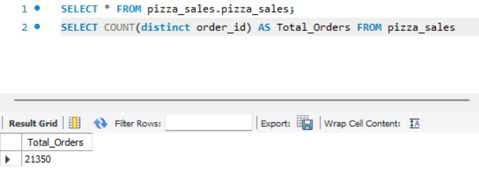

**5. Average Pizzas Per Order**

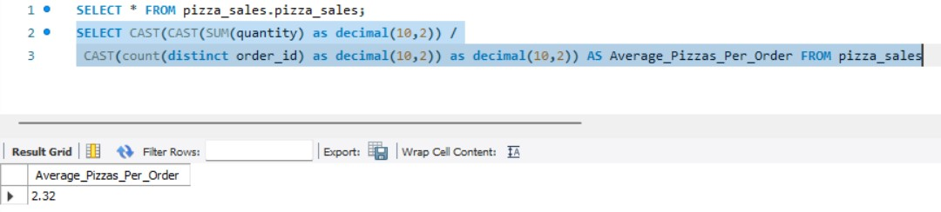

**B. Daily Trend for Total Orders**

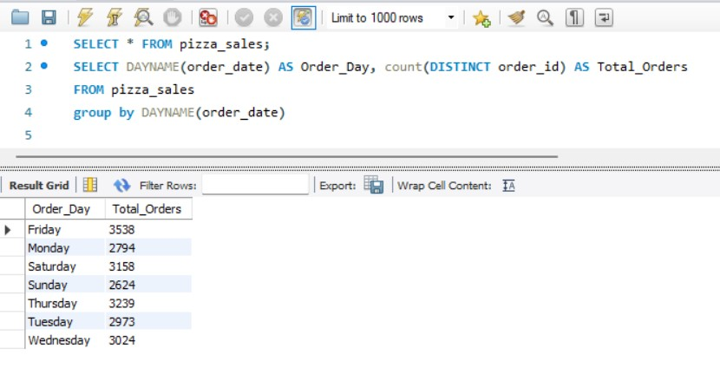

**C. Hourly Trend for Orders**

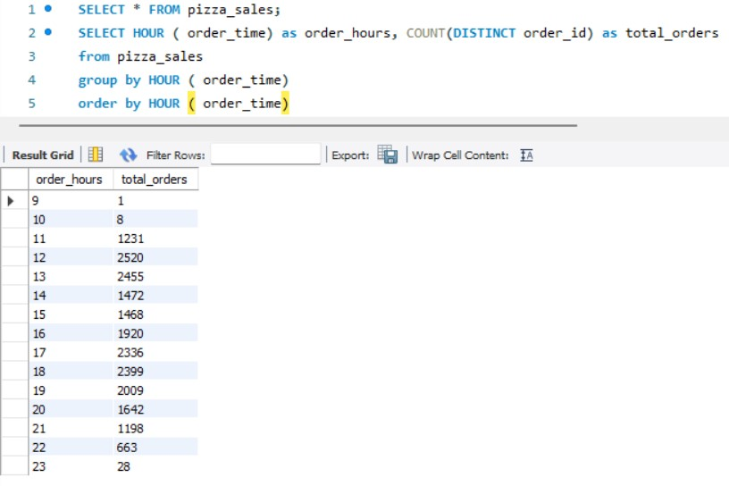

**D. % of Sales by Pizza Category**

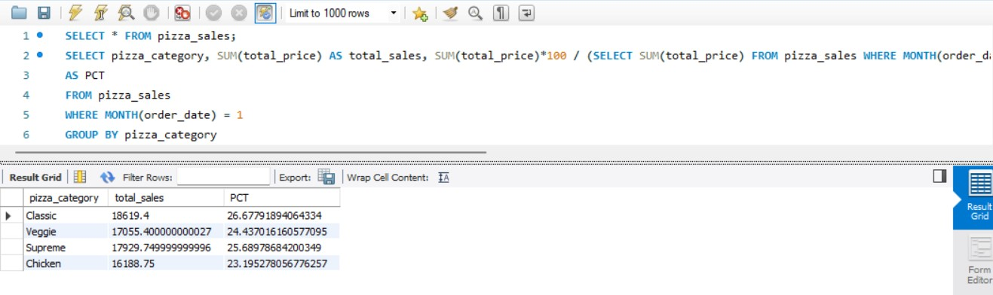

**E. % of Sales by Pizza Size**

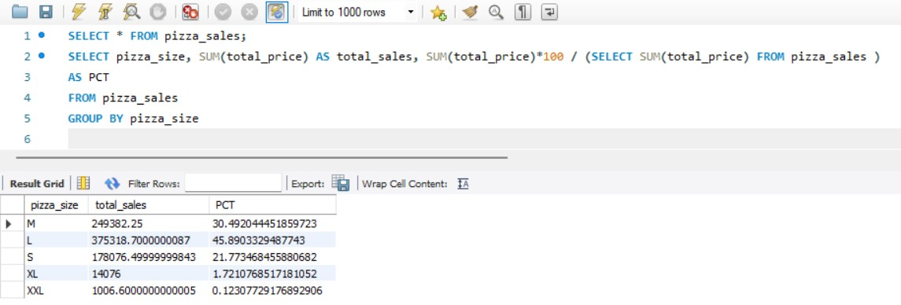

**F. Total Pizzas Sold by Pizza Category**

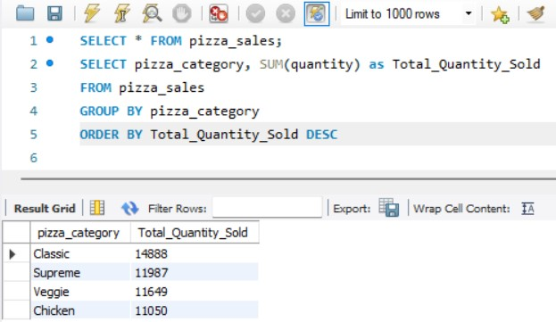

**G. Top 5 Best Sellers by Total Pizzas Sold**

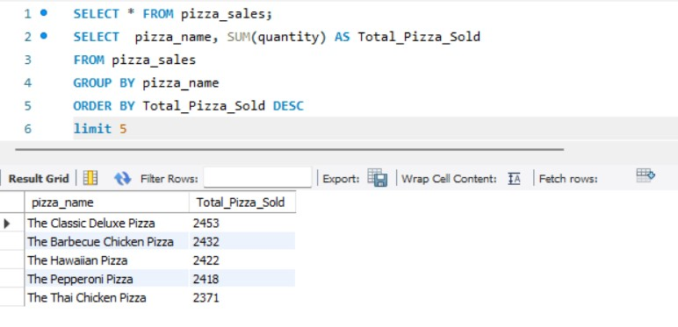

**H. Bottom 5 Best Sellers by Total Pizzas Sold**

